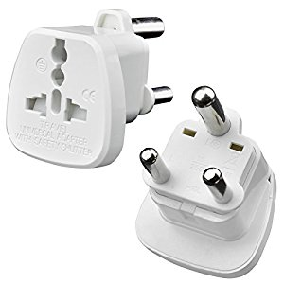

UK 3 pin to type M adaptor
Same as South Africa

